|  |  |
| --- | --- |
|  | BrewSpinDome |
|  | RotationFront.pngIMG_0891.JPG |
| 10/2/2016 | Foster Systems Dome Driver Replacement |
|  | Documentation for the hardware and software for the ASCOM Dome driver BrewSpinDome. This driver does both Rotation and Shutter control. |

Table of Contents

[Introduction 2](#_Toc463349297)

[Hardware 3](#_Toc463349298)

[Rotation Controller 4](#_Toc463349299)

[Rotation Controller and Sensor Schematic 6](#_Toc463349300)

[Rotation Controller and Sensor Wiring Plan 7](#_Toc463349301)

[Rotation Position Sensor 8](#_Toc463349302)

[Shutter Control 11](#_Toc463349303)

[Shutter Operation 13](#_Toc463349304)

[Shutter Schematic 14](#_Toc463349305)

[Shutter Controller Wiring Plan 15](#_Toc463349306)

[Software 16](#_Toc463349307)

[BrewSpinDome 16](#_Toc463349308)

[BrewSpinControl 16](#_Toc463349309)

[Controls 17](#_Toc463349310)

[Indicators 17](#_Toc463349311)

[Arduino Sketches 19](#_Toc463349312)

[Rotation Code 19](#_Toc463349313)

[Shutter Control Code 19](#_Toc463349314)

[Installation 20](#_Toc463349315)

[Copy Files 20](#_Toc463349316)

[ASCOM 20](#_Toc463349317)

[Loading Arduino Code 21](#_Toc463349318)

[Loading the Arduino IDE 21](#_Toc463349319)

[Load cc3000 library 22](#_Toc463349320)

[Loading the Sketches 22](#_Toc463349321)

[Configuring Driver 23](#_Toc463349322)

[Testing Hardware and Driver 23](#_Toc463349323)

[Manual Rotation Test 23](#_Toc463349324)

[Manual Shutter Test 23](#_Toc463349325)

[BrewSpinControl Test 24](#_Toc463349326)

[Determining Number of Blocks 26](#_Toc463349327)

[Determining Dome Offset 26](#_Toc463349328)

BrewSpinDome

Foster Systems Dome Driver Replacement

# Introduction

For some time I have been frustrated with the Foster Dome Control system. The hardware worked well, but the software tended to be buggy and awkward to use. Every time I updated the usage pattern changed and different problems surfaced. I was not allowed to leave it at a working version; Foster stops the program from running if it gets a couple of versions out of date.

I finally decided to build my own system using Arduino microprocessors and the existing hardware. I first implemented a Shutter Controller since that is where most of the problems occur. Once that started working I built a replacement Rotation controller. It turns out the Rotation controller is much simpler, with fewer inputs and less complex decisions. In my case the Shutter Controller is also more difficult because it only gets powered when the dome is in the Home position. I do not use a battery mounted on the dome wall.

# Hardware

BrewSpinDome ASCOM driver

Client (ACP)

BrewSpinControl

Rotation Controller (Arduino Uno)

Shutter Controller (Arduino Mega)

Rotation Sensor

Home Sensor

DC Motor

12V Power Supply

4 Shutter Switches

DC Motor

*WiFi*

*USB*

Figure . Block Diagram of the system.

The diagram above shows the system components. The system continues to use much of the Foster System hardware (shown in blue):

* Motors
* Home Sensor
* Dome gear sprocket
* Upper and lower shutter switches

The Foster control boxes are replaced with home built units based on Arduino microcontrollers. I also created a replacement mechanism for sensing the dome position.

## Rotation Controller

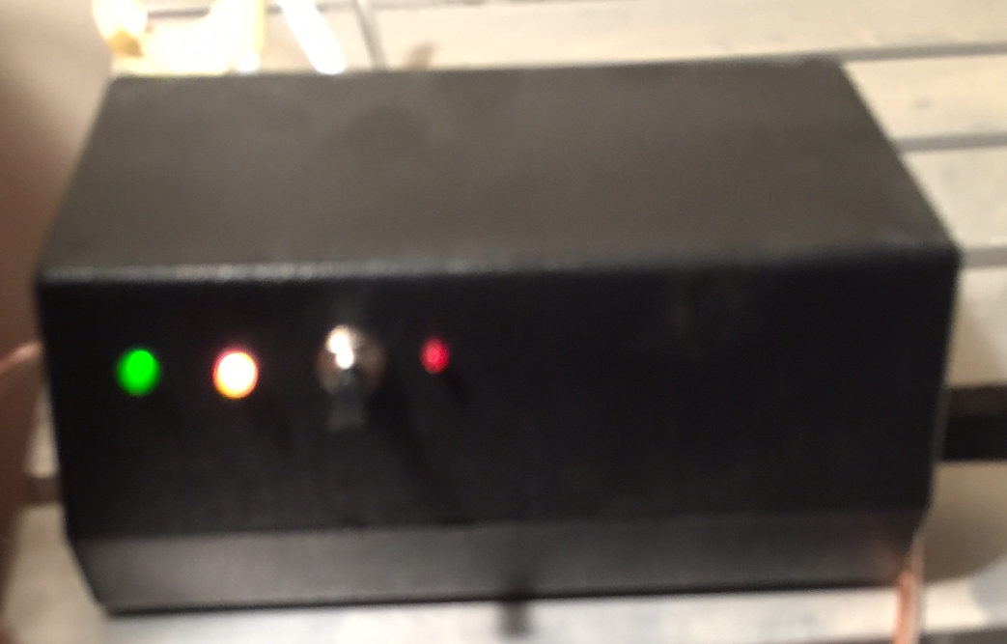

Figure . Rotation Controller containing Arduino Uno processor.

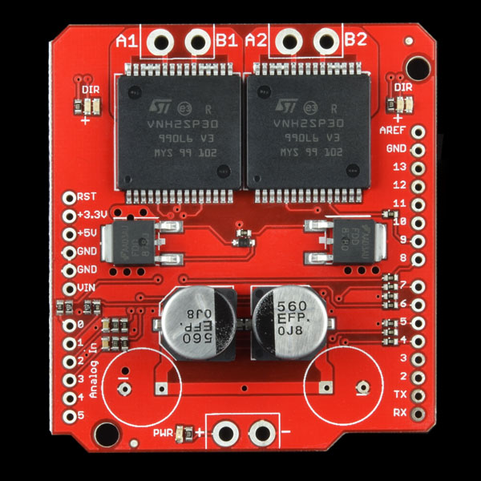The rotation of the dome uses an Arduino Uno controller with a Sparkfun MonsterMoto shield. This shield allows the larger current to the DC motor used to drive the dome. Typical motor shields handle smaller currents for robots, etc.

The Arduino communicates to the ASCOM driver via RS232/USB. It connects to the existing Home sensor; another cable connects to the rotation sensor. Two other cables connect to the 12V power supply and the motor.

Figure . Sparkfun MonsterMoto shield controls high current DC motors.

The Arduino draws power from the USB port; the power supply is only used to provide power to the DC motor.

The Rotation Controller is housed in a small box as shown:

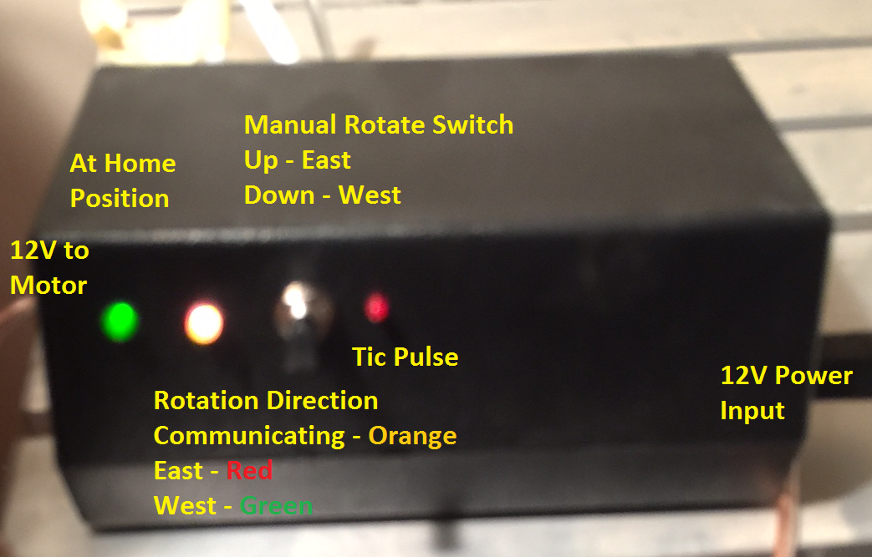

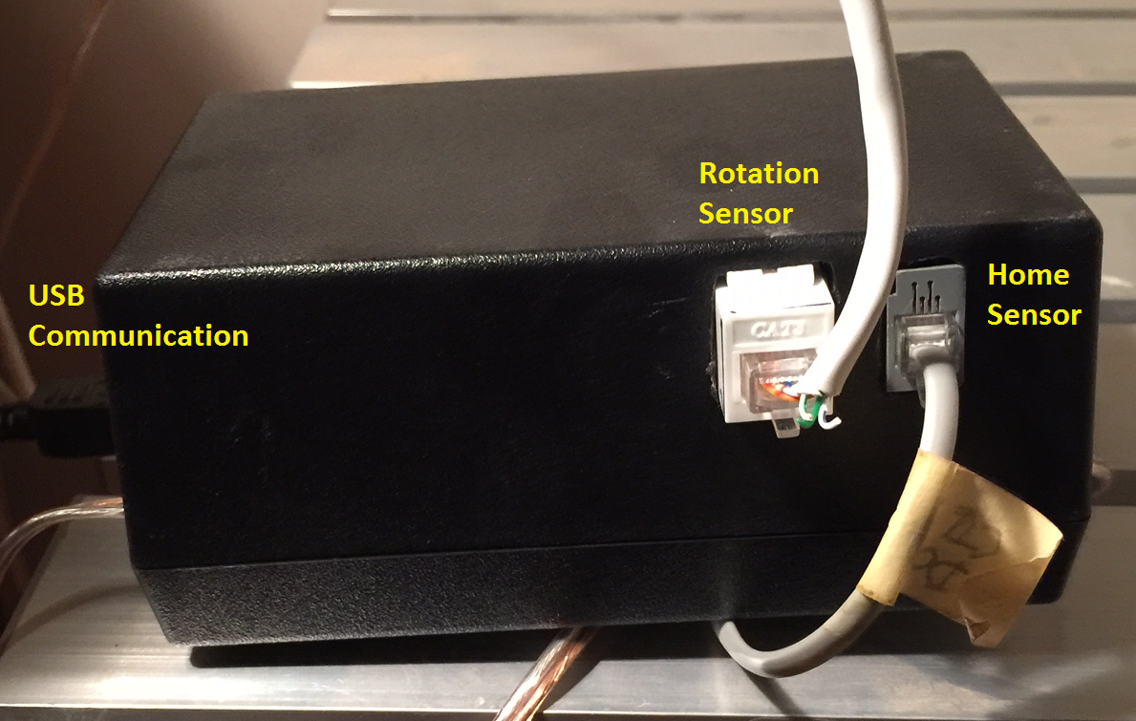

Here are the schematic and wiring plans for the controller.

## SpinDomeSchematic.pngRotation Controller and Sensor Schematic

## SpinDomeWiringPlanMainBoard.jpgRotation Controller and Sensor Wiring Plan

### Rotation Position Sensor

Rather than use the existing position sensor I built a replacement sensor. This allows a factor of 3 or 4 improvement in the resolution of the sensor. I see that subsequently Foster has come out with a similar style sensor. I’m sure theirs is better machined, etc. It looks to be similar resolution to mine.

A sensor “fence” was cut from the bottom of a plastic flower pot of the correct diameter. The bottom piece was cut with a Dremel tool to get the toothed shape. The piece was painted flat black and mounted on top of the dome driving gear.

The sensor employs an infrared LED emitter and detector. These are placed on either side of a rotating sensor wheel, the emitter outside the wheel and the detector inside. The detector pulses on and off as the wheel turns. Each on/off pulse generates 2 interrupts, one for the high pulse and one for the low pulse.

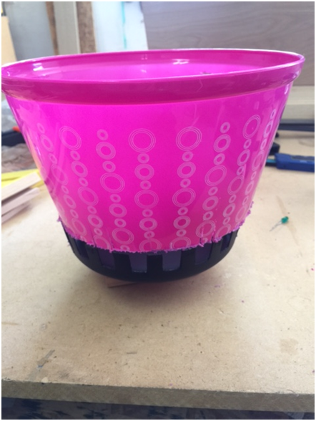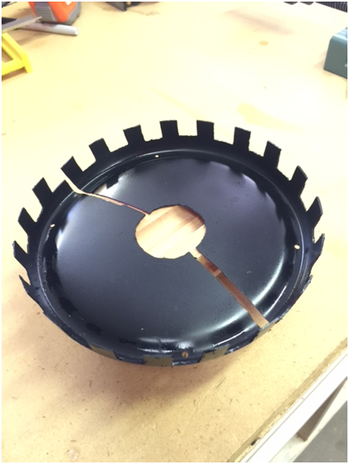

Figure . Dome Position sensor construction. The “teeth” are about 1 cm wide.

The pulses are run through a Schmitt Trigger and a 555 timer chip to clean up the signal, making a nice square wave for the Arduino to react to. Since the wheel was hand cut, the pulses are not identically sized. This is not important.

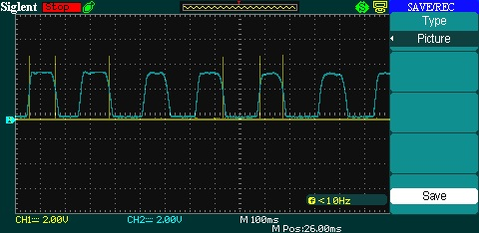

Figure . The original pulses were "rounded", making interrupts irregular. Note that interrupts are generated on both the rise and fall of the signal (shown by the yellow spikes).

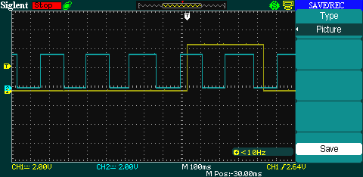

Figure . Addition of a small circuit board at the fence wheel with a Schmitt trigger and a 555 chip cleaned up the signal. The yellow trace is the home sensor. The interrupt spikes are not shown on this trace.

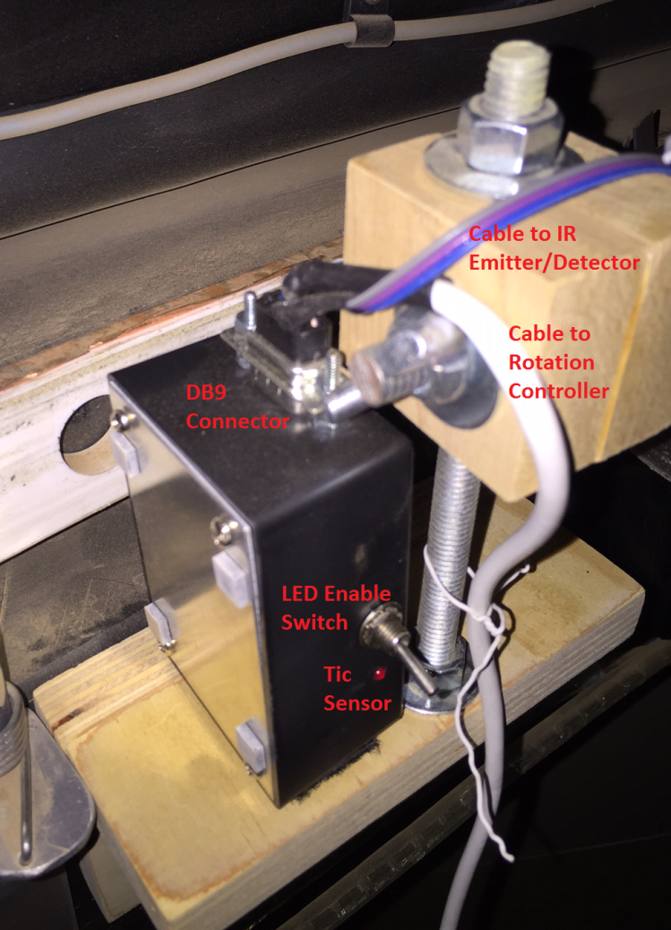The sensor circuit is enclosed in a small plastic box. A small LED displays the pulses (the LED flashes as the dome turns). A switch can turn off the LED to reduce the amount of light when imaging. I just turn the LED on when checking operation of the sensor.

Figure . Rotation Sensor mounted on a shelf attached to the dome ring. The top cable runs to the sensor emitter / detector LEDs.

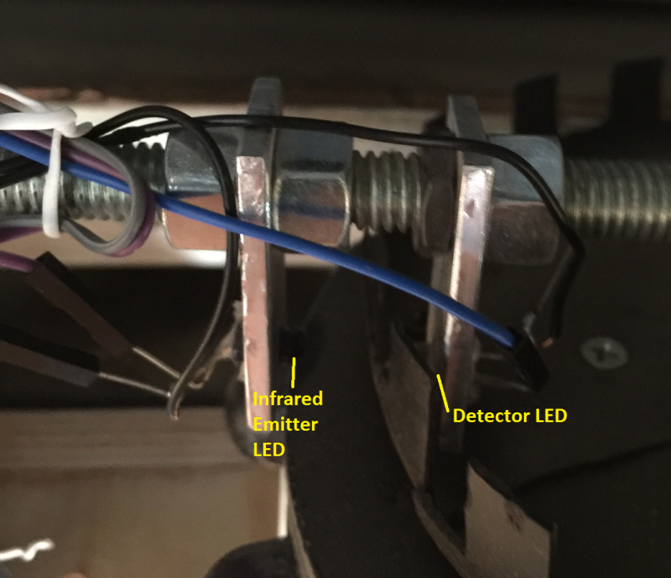A DB9 connector is connected to two cables. One longer cable runs to the rotation controller. It brings 5V power and ground to the circuit and returns the pulse signal. The other short cable runs power and ground to the emitter/detector LEDs, and returns the emitter voltage.

Figure . Infrared Emitter and Detector LEDs. The mounting bolts allow precise positioning of the LEDs relative to the fence.

## Shutter Control

The Dome Shutters are controlled by a controller based on an Arduino Mega. The two shields used with the Arduino use almost all of the pins regularly available on the Arduino. The Mega provides enough additional IO pins for shutter switches, various light LEDs, etc.

The controller is housed in an L-shaped box which fits snugly into the existing bracket on the dome wall. I attached a small mirror adjacent to the controller so the status LEDs are visible to an IP camera in the dome.

The only wiring to the controller from the main dome is 12V power supplied by a power supply (no USB, sensor lines, etc.). The power connection only occurs when the dome is in the Home position. Thus, a difficult design issue is that the shutter only operates when in the Home position. The controller needs about 20 seconds after power is applied to power up and initialize.

The two shields on the Arduino Mega are:

1. 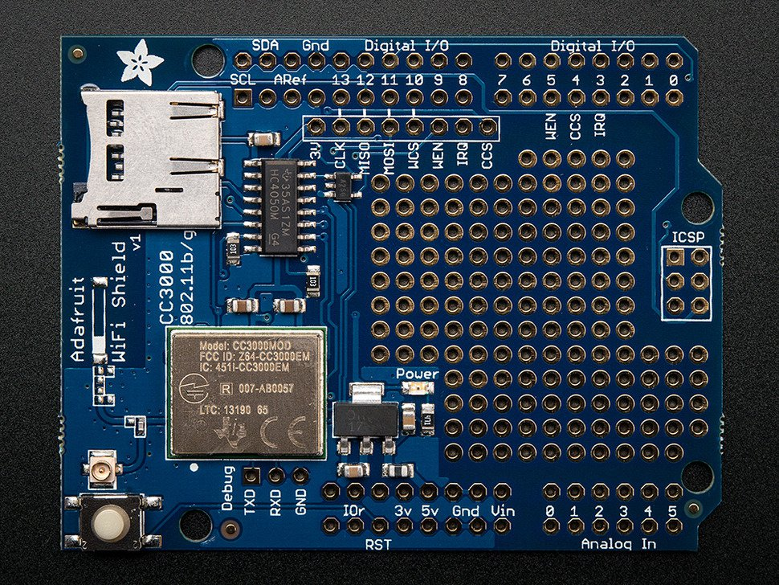A CC3000 shield from Adafruit (product ID 1534). This provides WiFi LAN connectivity; I assigned IP address 192.168.1.30 to the controller. Because the controller is mounted on the dome wall, I cannot use the typical communications to the Arduino such as the USB Serial port. When software needs to communicate with the shutter it uses Tcp IO; the model for this communication is based on an Echo server sample project from Adafruit. I used the external antenna version since it is supposed to get better range (buy the antenna separately).

Figure . Adafruit cc3000 WiFi shield with external antenna connector

1. A Monster Moto shield from Sparkfun (same shield is used in the Rotation Controller). This shield (see Figure 3) provides high current control over two DC motors. Conveniently, the shutter controls two motors, one for the upper shutter and one for the lower. This shield takes 12V input and applies it to the motors as programmed. It can use PWM control to start and stop the motor rather than abruptly starting the motor.

The diagrams for the circuits are shown below.

* The switches are 3 position single pole, with positions Left, Off, Right. These allow manual control of the shutters without computer interaction.
* The 9V battery is just because I couldn’t find a Fritzing battery with 12V. It should be 12V. The 12V supplies both the motors and the Arduino. The power supply is routed using a terminal block.
* The 12V is regulated to about 7V using a SWADJ3 regulator. This allows the Arduino to do the final regulation to 5V without creating too much heat.

### Shutter Operation

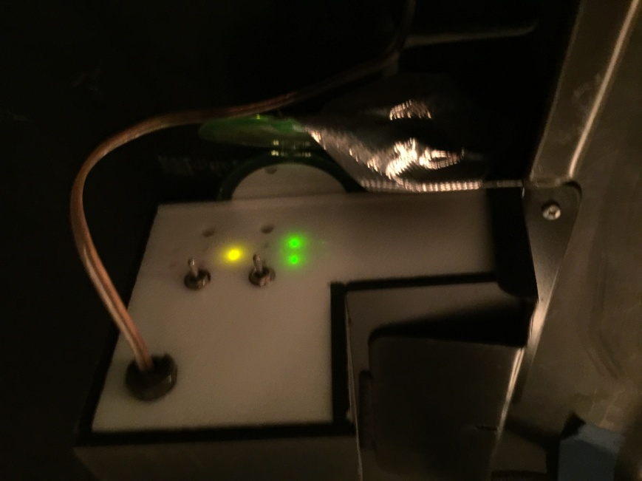The two switches can be used to manually open/close the shutters. In some situations the switch is disabled – for example, trying to open the lower shutter while the upper shutter is closed (this can damage the lower shutter). This is useful for testing the system.

The left side of the enclosure feeds two cables for powering the two shutters. It also has two RJ11 connecters for the 4 shutter switches, and the external antenna.

The right side of the enclosure has the input 12V supply and the two switches for manually controlling the two shutters. It also has several sets of LEDs:

Figure . Shutter Controller. Yellow LED is flashing in default operation. The two green LEDs indicate both shutters are closed. The upper switch manually opens/closes the Upper Shutter; the lower switch controls the Lower Shutter.

The central yellow LED indicates the status of the controller. It is solid while the Arduino is initializing. It flashes 1 or 2 times per second while the controller is checking for (and executing) commands).

The left column of 4 LEDs displays operation of the Upper Shutter. The right column shows the same information for the lower Shutter.

* The top Red LED indicates the Open Shutter switch is triggered (the shutter is in the open position).
* The second Red LED flashes rapidly while the shutter is opening.
* The next (green) LED flashes rapidly while the shutter is closing.
* The bottom green LED indicates the shutter is in the closed position.

## Shutter Schematic

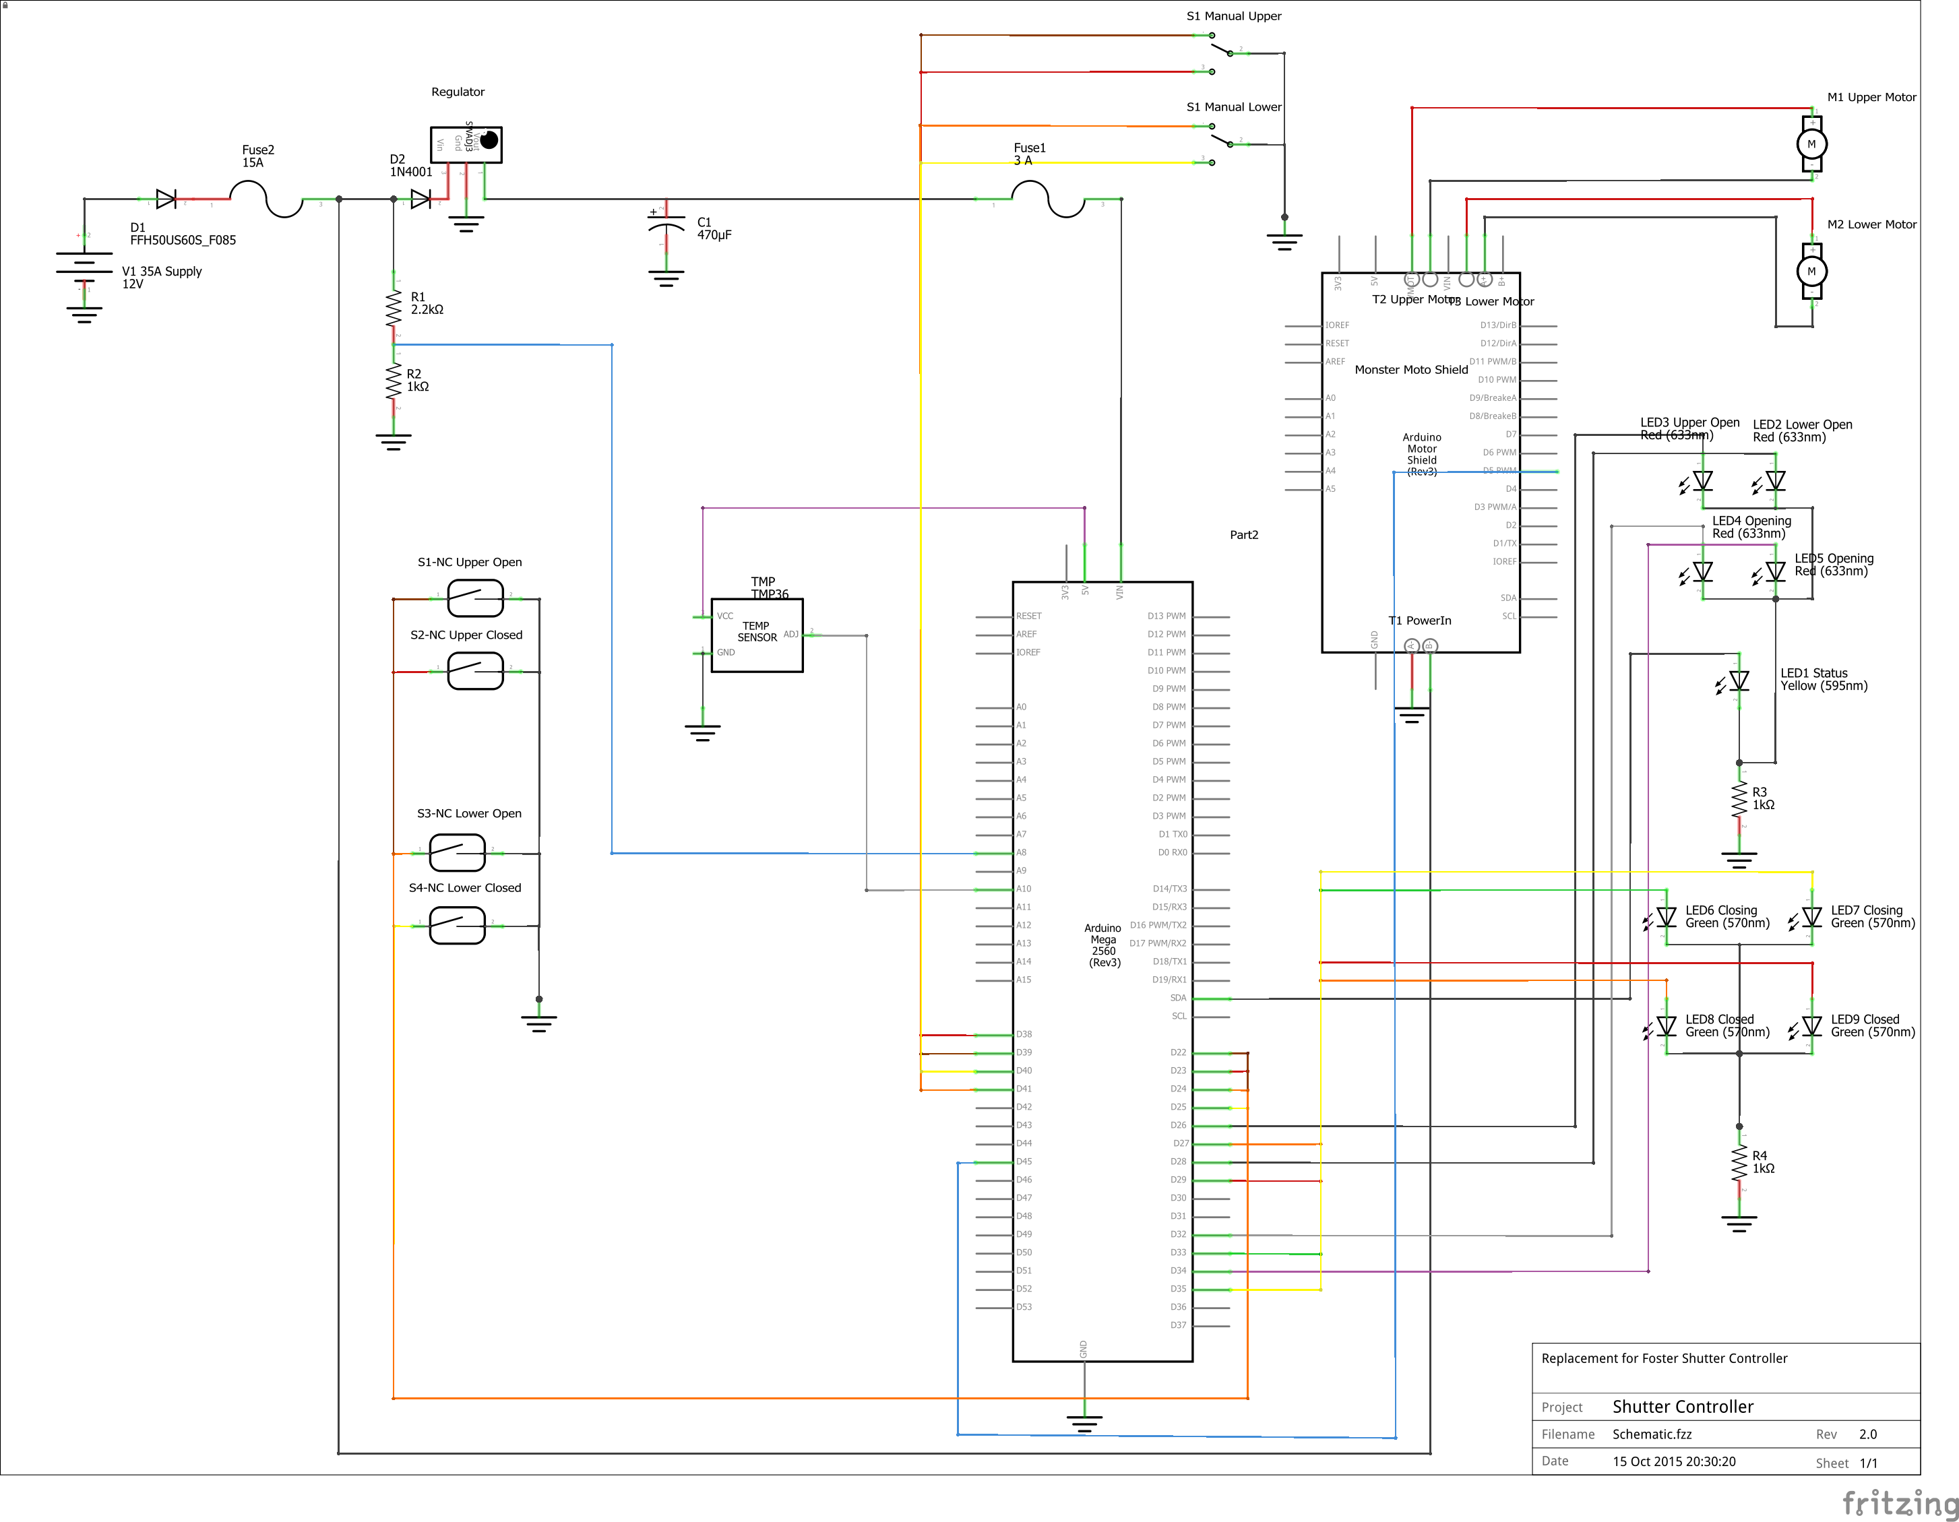

Figure . Shutter Controller Wiring Schematic.

## Shutter Controller Wiring Plan

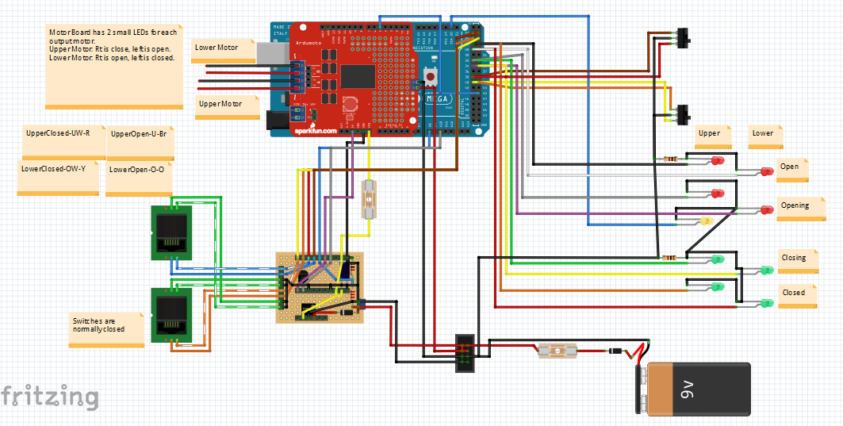

Figure . Shutter Controller Wiring plan. 9V battery is actually 12V power supply.

# Software

A new ASCOM driver (BrewSpinDome) was written to control the dome. It follows the ASCOM standard, although it does have some extra Actions to allow more detailed status type information to be retrieved and a couple of extra movements to be accomplished.

BrewSpinDome is intended to be used by various programs like ACP in the usual way. In addition, a separate application program is provided (BrewSpinControl) which uses the dome driver to control the dome. This is likely to be used in problem solving situations or manually controlling the dome.

## BrewSpinDome

BrewSpinDome is a standard ASCOM driver for dome control written in VB.NET.

It has several special Actions which allow BrewSpinControl to display extra status information and perform special movements of the dome. These are not used by other programs (i.e., ACP).

## BrewSpinControl

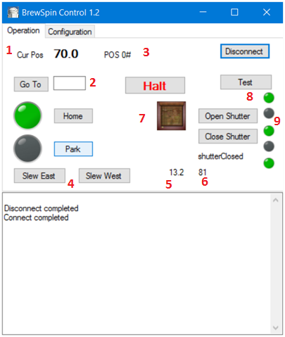BrewSpinControl is a “test” program which connects to the dome via the BrewSpinDome driver. It cannot run at the same time as other programs (such as ACP). The BrewSpinDome driver is not a hub. The other program must disconnect before BrewSpinControl can connect.

This program provides typical Dome operations, as well as a few non-standard abilities using custom Actions in the driver.

Controls

**Home**. The dome rotates in the West direction until it reached the Home position.

**GoTo** (**2**). Specify the target Azimuth position in the text box, then click the GoTo button to rotate the dome to that position. It should take the shortest route East or West. In this image the dome is at the Home position, which happens to be at azimuth 70 degrees.

**Park**. Rotate the dome to the designated Park position.

**Slew East/West (4)**. Starts rotating the dome in the desired direction. The dome does not stop until the Halt button is clicked.

**Open/Close Shutter**. Performs the shutter operation. Both shutters are moved. Several images may appear in the image(**7**).

Red light. Shutter status is unknown, and the shutter is not moving.

Homing. If the dome is not at the Home position, it is first homed.

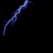 Power. Waiting 20 seconds for the shutter to power up.

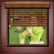 Shutter movement. The shutter is opening/closing.

 Open/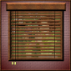 Closed. The shutter is open or closed.

**Halt**. Stops all motor activity, both rotation and shutters. You may want to open the upper shutter slightly for air or light.

**Test**. Not used.

### Indicators

**POS(3)**. The current tic position of the dome is displayed. Home is defined as 0. For example, the dome might be positioned 350 tics away from home. For internal debugging only, not generally useful to the user.

**Voltage(5)**. The voltage measured at the shutter controller is displayed. Assuming the shutter is at Home, this should be roughly 12 volts (typically a bit higher).

**Current(6)**. This shows the current being drawn by the shutter motors (not the rotation motor). Currently this value is not scaled to any useful units, but you should see it change when the motors are running.

**Arduino connection(8)**. If the Arduino is currently communicating the topmost light is green.

**Shutter Switches(9)**. The 4 switches are presented: Upper Open, Upper Closed, Lower Open, and Lower Closed. If the switch is triggered the light is green. Hover the mouse over the light to determine which switch is shown.

If the Arduino is unavailable (powered off when not at Home) the lights are shown dimmed, based on the last known status.

## Arduino Sketches

Each of the two Arduino controllers runs a separate program (called a sketch). This code is saved in the Arduino even when it is turned off; when the Arduino is powered on the code immediately begins to run. The code only needs to be downloaded into the Arduino once.

### Rotation Code

SpinDome.io Main logic. Open this file in the Arduino IDE.

DomeIO.ino Communications to the Arduino

SerialIO.ino Communications to USB (Serial).

### Shutter Control Code

ShutterControl.ino Main logic. Open this file in the Arduino IDE.

Cc3000Server.ino Handles WiFi communications. Modified form of the library code.

ShutterIO.ino Routines to talk with Arduino

Also uses Adafruit\_CC3000 library (from Adafruit) for low level WiFi routines.

# Installation

First, of course, you need to build the Rotation and Shutter controllers. I built mine in Breadboard form while I debugged the system, then built the permanent perfboards later. Once all the hardware is in place, several steps are required to implement the BrewSpinDome driver.

Note that the Home Sensor magnet must be installed so the dome is positioned at Home where power is supplied to the shutter controller.

## Copy Files

Copy the following files to these locations:

## ASCOM

Of course, you need to load the ASCOM platform. I am currently running version 6.1. The installation should include several tools, including the Profile Explorer.

## Loading Arduino Code

### Loading the Arduino IDE

The Arduino IDE allows easy programming and uploading of programs to the Arduino. Download the IDE from <https://www.arduino.cc/en/Main/Software>. At this time I am running version 1.0.6. Follow their instructions to install the software.

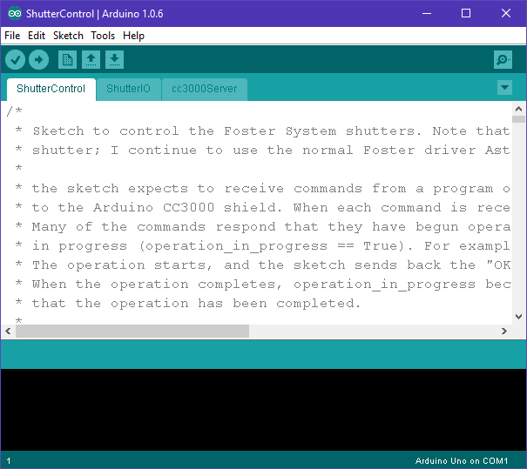

Figure . Arduino IDE. The ShutterControl.ino sketch has been loaded; notice that the associated files ShutterIO and cc3000Server have automatically been loaded as well. At the lower right note the board and serial port being used.

### Load cc3000 library

You also need to download the cc3000 library from Adafruit at <https://learn.adafruit.com/adafruit-cc3000-wifi/cc3000-library-software>. Install the library as they describe.

The cc3000 download includes several example sketches which can be used to test the cc3000 shield. This can be done by installing the shield on the Arduino (the entire controller does not have to be present). Follow their directions to test your IDE and the cc3000 shield. One of these tests is important since it allows you to set the IP Address for the card.

### Loading the Sketches

1. 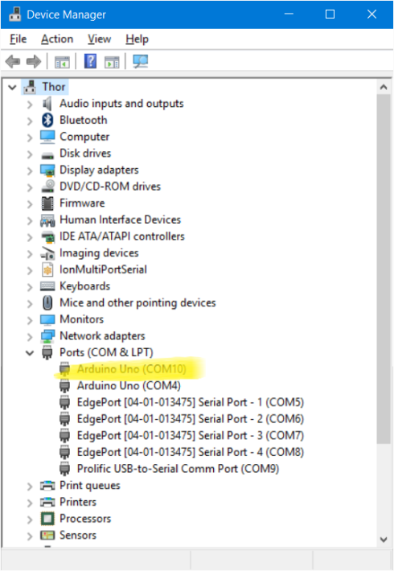Run a USB cable between an Arduino and the USB port you intend to use for the Rotation Controller. In the IDE check the Tools menu to verify that a) the correct board is selected (Uno or Mega) and b) the correct COM port is selected for serial communications. Double check the COM port by looking at the Device Manager as shown.
2. Load or type in the Blink example sketch (Arduino programs are called sketches) and make sure the sketch runs correctly (it will blink the LED light next to pin 13 on the Arduino). This ensures your IDE and Arduino are working correctly.

Rotation Controller COM Port: \_\_\_\_\_\_\_

1. Repeat the previous step using the USB port you intend to use for the Shutter Controller. Note which COM port the computer has assigned this Arduino.

Figure . Device Manager showing the COM Port for the Arduino.

Shutter Controller COM Port: \_\_\_\_\_\_\_

Remember that using a different USB connector or installing a USB Hub will result in a different COM port.

#### Loading Shutter Arduino Mega

1. Connect the ShutterController Arduino Mega with a USB cable. This is only needed to load the code into the Arduino. Use Device Manager to verify which COM port is assigned to the Arduino. This can be done with the Arduino on its own. It does not need to be wired and installed into the controller.
2. Run the Arduino IDE. Open ShutterControl.ino.
3. Set the LAN Address and Port number in ShutterControl.ino. This identifies the WiFi address of the Arduino. Later, this same information needs to be set for the BrewSpinDome driver so they can communicate.
4. Save the file with your changes.
5. Use Tools/Set Board to make sure you are addressing the Arduino Mega.
6. Use Tools/Serial Port to select the correct COM port.
7. Click the upload icon to a) build the code, and b) upload to the Arduino. While uploading the Tx/Rx lights on the Arduino should flash (may be hard to see on the main board under the shields). *Optional*: if the Arduino is already built into the controller the yellow Status light should be steady for about 20 seconds while the program initializes, then flash steadily about once a second.
8. Remove the USB cable.
9. When you have determined some of the configuration parameters for the shutter (for example, the number of blocks per rotation) you may need to modify the initial settings in the code and re-upload the file to the Arduino. This way the Arduino always has the correct values.

#### Loading the Rotation Controller

Loading the Rotation controller is very similar to the Shutter Controller. The Arduino IDE should already be loaded.

1. Connect the Rotation controller Arduino Uno with a USB cable. Connect the power supply and motor cables.
2. Run the Arduino IDE. Open the sketch SpinDome.ino.
3. Select the correct port in Tools/Serial Port. Make sure the Arduino Uno is selected in Tools/Board.
4. Build and upload the sketch to the Arduino.
5. *Optional*: if the Arduino is built into the Rotation Controller the Direction Light should flash Orange, indicating the Arduino is running and the dome is not moving.

## Configuring Driver

May need to modify code, reload ArdCode?

## Testing Hardware and Driver

Turn on power to the Dome. The Rotation Controller Direction Light should show Orange, indicating the Arduino is running and the dome is not moving.

### Manual Rotation Test

Use the movement switch on the Rotation Controller to move the Dome in the East and West directions.

* The Red LED should flash on the Rotation Sensor box. You might need to toggle the switch position to enable the LED. In addition, the small Red LED flashes on the Rotation Controller. These indicate that pulse signals are being detected as the dome moves.
* The Direction Light should change from orange to either Green or Red while the Dome moves West or East respectively.
* Position the dome so the Home Sensor should be activated. The Green Home Light should come on.

### Manual Shutter Test

Rotate the Dome so it is *not* in the Home Position. Now move the dome manually to the Home Position, or at least close enough so power is supplied to the shutter.

1. Looking at the Shutter Controller lights, the yellow LED should be solid yellow for 15-20 seconds while the controller initializes. Subsequently the LED should flash roughly once or twice a second as the controller checks for commands. Assuming the shutters are closed, the two Shutter Closed LEDS should be green.
2. Use the Upper Shutter movement switch to raise and lower the upper shutter. When the switch is in the middle position the shutter stops; the other two positions open and close the shutter.

* The Upper Shutter Opening LED should flash red while the shutter opens.
* When the shutter is completely open, the Upper Shutter Open LED should show steady red.
* While the shutter is closing the Upper Shutter Closing LED should flash green.
* When the shutter is completely closed the Upper Shutter Closed LED should show steady green.

1. With the Upper Shutter open (or at least partially open) use the Lower Shutter movement switch to open and close the Lower shutter. Note the same LED patterns for the Lower Shutter LEDs.

### BrewSpinControl Test

1. Run BrewSpinControl. In the Configuration tab use the Chooser to select the BrewSpinDome driver. In the Properties window select the correct COM port for the Rotation controller Arduino Uno. Also fill in the IP Address and Listen Port for the Shutter Controller. These should be set to the same values you set when you tested the cc3000 shield (see ***Loading the Arduino IDE***, page 17).
2. On the Main tab click Connect. A message should appear in the log window, and various controls become active.
3. If the dome is not at Home, click the Home button. Dome should move to the Home position. The Home Light should turn on (both on screen and on the Rotation Controller box).
4. Wait 20 seconds – the shutter status should update, indicating successful communication to the Shutter.
5. Try clicking “Slew East”. The dome should start rotating to the East (if you are facing South). The Direction light on the Rotation Controller should turn Red, and the small Red LEDs on the Rotation Controller and the Rotation Sensor should blink as pulses are detected from the moving dome. The Azimuth position should update constantly every second or so. The dome continues rotating until you click Halt.
6. After halting the dome, click Open Shutter. The dome should go through several steps to open the shutter:

* Homing the dome (shows Homing icon). Shutter Status shows “shutter opening”.
* Waiting 20 sec for power up (shows lightning icon ).
* Begins opening shutter (shows animated opening icon ).
* Shutter is open (shows Open shutter icon , status becomes “shutter open”).

1. Closing the shutter performs the same steps, but closing instead.

Note: the BrewSpinDome driver creates a log file in Documents/ ASCOM/ datestampname.txt. This can be helpful for debugging issues. A new file is created every time a program connects to the driver.

### ControlConfig.pngDetermining Number of Blocks

You need to determine the number of “blocks” or tics it takes for the dome to make one rotation. By default the Rotation Arduino sketch is set to the value of 490, which matches my dome (the Rotation Sensor generates 490 pulses for a complete rotation of the dome). Whenever the driver connects to the Arduino this value is updated to your particular value. Your dome is almost certainly a different value.

1. Open BrewSpinControl, connect to the driver, and go to the Configuration page.
2. The current Tics count is displayed under the Count Tics button.
3. Click the Count Tics button. The Dome will go through several gyrations of homing and rotating the dome.

In the end the new Tic count is displayed and updated in the Driver profile. You can use the ASCOM Profile Explorer to verify that the value has been updated correctly, or to change the value as desired.

### Determining Dome Offset

Your dome is installed at some arbitrary angle relative to North. In addition, your Home Sensor is installed at some arbitrary position on the dome. As a result there is an offset between the dome’s angle position and the actual angle relative to the sky.

For example, suppose we slew our telescope to a target in the sky. ACP (or other programs) does the fancy math to determine the target azimuth of 130 degrees for positioning the dome. The telescope is slewed to point at the target, and the dome is slewed to 130 degrees. However, the dome ends up off (in this example) by 20 degrees. This is because the Home sensor is 20 degrees off from the real 20 degrees position.

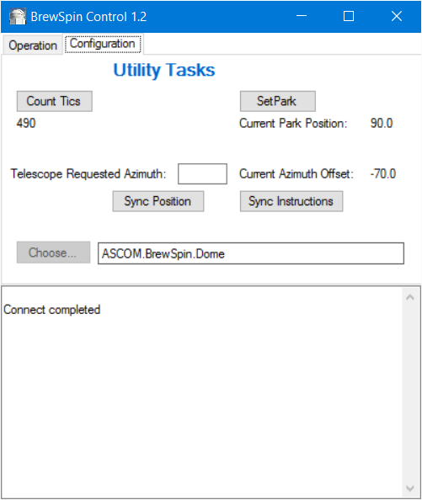Fortunately we do not need serious math to correct for this – the offset will always be 20 degrees. We just need to determine the offset and save that value.

Figure . The Sync Instructions button brings up the steps required.

#### Method 1- Automatic Way

For this calibration, leave the shutter closed. It is helpful to have a laser pointer available.

1. First, we want to determine the correct value for a particular target. In ACP connect to the telescope with the Dome driver set to BrewSpin.Dome. Select a target, perhaps in the Southern sky (I think Southern targets require more precision). I use a star very near the meridian, low in the South. This results in the mount being almost horizontal, creating the greatest oblique angle of the OTA with the shutter. Slew the telescope to the target in ACP. The dome should slew to some odd position, almost certainly not aligned with the scope.
2. Click on the Dome Control button on the ACP console. In this window note the azimuth – this is the correct azimuth of the dome to align with this target. As an example, assume it reads 130.
3. Disconnect the telescope in ACP. Open BrewSpinControl, connect, and go to the Configuration screen.
4. Check the Sync Instructions to make sure things haven’t changed☺
5. Reposition the dome using the controls on the Operation Tab. I find it easiest to type azimuth values in the GoTo box.
6. Make sure the OTA is precisely positioned in the center of the shutter. Use the laser pointer placed alongside the edges of the OTA to ensure it is centered on the shutter; often “eyeballing” is misleading. In our example, assume the azimuth reads 150 in BrewSpinControl.
7. Return to the Configuration Tab and click Sync. The Offset is now 20, meaning that when ACP asks for azimuth 130 we position at 150.
8. Returning to the Operation Tab, the displayed azimuth should now show 130. You might need to disconnect and reconnect to pick up the new offset.

Now, exit BrewSpinControl and reconnect in ACP. Try slewing to various targets, checking the scope centering on the shutter.

#### Method 2 – The Simpler Way

This method is less “automated” but I find it simpler.

1. As before, connect ACP to the scope using BrewSpin.Dome to run the dome.
2. Select a target and slew the telescope to it. Note the azimuth in the Dome Control dialog.
3. Disconnect ACP and connect with BrewSpinControl.
4. 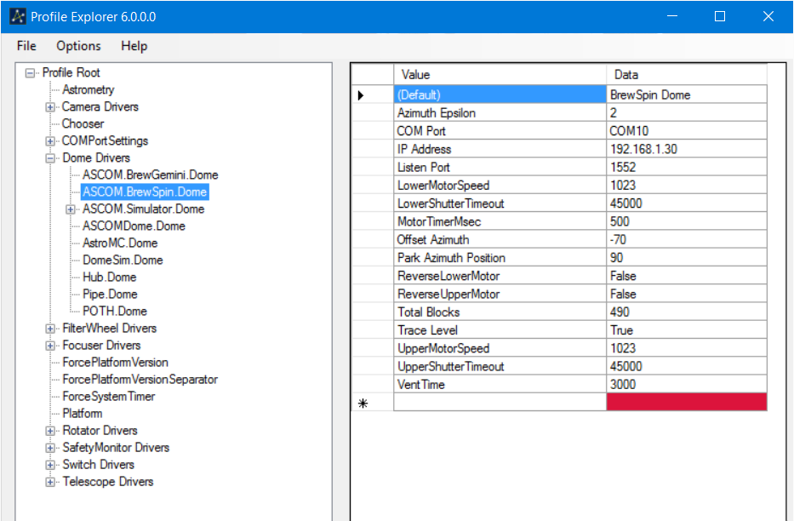Bring up the ASCOM Profile Explorer. Under Dome Drivers select ASCOM. BrewSpin.Dome. Locate the setting for *Offset Azimuth* (on my system it is -70).

Figure . Profile Explorer settings for the dome driver.

1. Align the OTA with the shutter by re-positioning the dome. Again, when it gets close I find it useful to enter azimuth values in the GoTo box.
2. When the OTA appears aligned, subtract the current azimuth from the “correct value to get the offset. Update the value in the *Offset Azimuth* setting. This is your starting estimate of the offset. **Note: You may need to reverse the sign of the difference.**
3. Disconnect and reconnect BrewSpinControl to refresh its offset value. Type the correct azimuth into the GoTo box and slew. Check the accuracy of the scope alignment with your laser pointer.
4. You probably need several iterations of adjusting the offset until it is accurate. For example, perhaps you started with an offset of 20. Enter 15 and try again; perhaps that is too far, try 17. Continue refining the offset until the OTA is well aligned.
5. You may wish to repeat the previous two steps with targets in different parts of the sky. In particular, try a position just on the other side of the Southern meridian. I have found that an accurate alignment with a Southern target results in a good value over the rest of the sky.